Firebase is a comprehensive mobile and web development platform that provides a wide range of services to help developers build, deploy, and scale applications quickly and efficiently. Developed by Google, Firebase offers a suite of tools, services, and infrastructure to simplify the development process and enable developers to focus on building high-quality applications. This report provides a detailed overview of the services offered by Firebase.

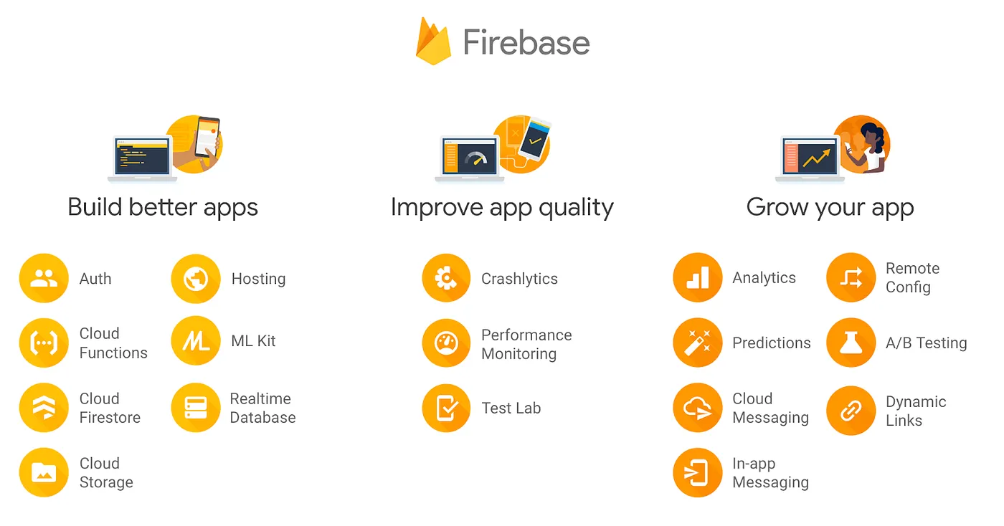

**Build your app — creating the “guts”**

The “build” group of products are these:

**Authentication** — user login and identity  
**Realtime Database** — realtime, cloud hosted, NoSQL database  
**Cloud Firestore** — realtime, cloud hosted, NoSQL database  
**Cloud Storage** — massively scalable file storage  
**Cloud Functions** — “serverless”, event driven backend  
**Firebase Hosting** — global web hosting  
**ML Kit** —SDK for common ML tasks

* **Firebase Authentication** is a service that provides secure user authentication and authorization for applications. It supports various authentication methods, including email/password, social media logins (e.g., Google, Facebook, Twitter), phone number authentication, and more. It simplifies the implementation of user authentication, allowing developers to easily add sign-up, sign-in, and password reset functionality to their applications.
* **Firebase Realtime Database** is a NoSQL cloud-hosted database that enables developers to store and synchronize data in real-time. It offers a flexible JSON data model and provides powerful data synchronization capabilities, allowing data to be automatically updated across connected clients. The Realtime Database is suitable for applications requiring real-time collaboration, chat, and other real-time data synchronization features.
* **Cloud Firestore** is a flexible and scalable NoSQL document database provided by Firebase. It offers a more advanced and feature-rich data model compared to the Realtime Database. Cloud Firestore supports automatic scaling, real-time data synchronization, offline data persistence, and powerful querying capabilities. It is an excellent choice for building complex applications that require scalable and real-time data storage.
* **Firebase Hosting** is a static web hosting service that allows developers to deploy and host web applications quickly. It provides a global content delivery network (CDN) for fast content delivery and supports custom domains, SSL certificates, and automatic scaling. Firebase Hosting simplifies the deployment process and provides a secure and reliable hosting solution.
* **Firebase Machine Learning (ML**) enables developers to integrate machine learning capabilities into their applications without extensive knowledge of ML frameworks. It offers pre-trained models for various tasks, such as image labeling, text recognition, and language identification. Firebase ML also provides an on-device ML Kit that allows developers to run ML models directly on users' devices, enabling offline and real-time ML inference.

**Grow your app — attract and retain users**

The “grow” group of products are these:

**Analytics** — understand your users, and how they use your app  
**Predictions** — apply machine learning to analytics to predict user behavior  
**Cloud Messaging** — send messages and notifications to users  
**Remote Config** — customize your app without deploying a new version; monitor the changes  
**A/B Testing** — run marketing and usability experiments to see what works best  
**Dynamic Links** — enable native app conversions, user sharing, and marketing campaigns  
**App Indexing** — re-engage users with Google Search integration  
**In-App Messaging** — engage your active users with targeted messages

* **Firebase Analytics** is a powerful app analytics solution that provides insights into user behavior, app usage, and user engagement. It tracks user interactions, screen views, and conversion events, allowing developers to understand how users engage with their applications. Firebase Analytics provides a user-friendly dashboard and supports integration with other Firebase services.
* **Firebase Predictions** leverages machine learning to provide user predictions and insights. By analyzing user behavior patterns, Firebase Predictions can predict user churn, segment users based on their predicted behavior, and provide personalized recommendations. This service helps developers deliver targeted messaging and experiences to their users, enhancing user engagement and retention.
* **Firebase Cloud Messaging (FCM)** is a cross-platform messaging solution that enables developers to reliably send notifications and messages to targeted devices. It supports sending messages to individual devices, user segments, or topic-based subscriptions. FCM supports both Android and iOS platforms and provides high delivery rates and low latency.
* **Firebase Remote** Config allows developers to customize the behavior and appearance of their applications without requiring an app update. It enables dynamic configuration changes, such as feature toggles, UI tweaks, and content updates, which can be remotely controlled from the Firebase console. Remote Config helps developers personalize the user experience and conduct A/B testing.
* **Firebase A/B Testing** allows developers to conduct experiments and test different variations of their application's UI, features, and configurations. It provides a simple interface to define experiments, set up control and variant groups, and track user engagement and conversion metrics. A/B Testing helps developers make data-driven decisions and optimize their applications for better user engagement and conversion rates.
* **Firebase Dynamic Links** allow developers to create deep links that direct users to specific content within their applications. These links can be customized based on user context or device type and can be used across different platforms, such as web, email, or social media. Dynamic Links simplify the user experience by deep linking to relevant app content and handling app installation if the app is not already installed.
* **Firebase App Indexing** enables developers to surface their application's content in Google Search results. By integrating App Indexing, developers can ensure that their app's content, such as deep links to specific screens or in-app search results, appears in relevant Google searches. This feature helps drive organic traffic and improves the discoverability of the application.
* **Firebase In-App** **Messaging** enables developers to engage with their users by sending targeted and personalized messages within the application. It supports various message formats, including banners, modals, and image cards, and allows developers to define trigger conditions based on user behavior or app events. In-App Messaging helps improve user engagement, promote features, and provide contextual information to users.

# Improve your app — stability and performance

The “improve” group of products are these:

**Test Lab** — scalable and automated app testing on cloud-hosted devices  
**Crashlytics** — get clear, actionable insight into your app’s crashes  
**Performance Monitoring** — gain insight into your app’s performance issues

* **Firebase Test Lab** is a cloud-based testing infrastructure that allows developers to test their applications on real devices hosted in the cloud. It supports automated testing for Android and iOS apps and provides a range of testing options, including compatibility testing, performance testing, and UI testing. Test Lab helps ensure the quality and reliability of applications across different devices and configurations.
* **Firebase Crashlytics** is a crash reporting and error tracking solution that helps developers identify and resolve application crashes and errors. It provides real-time crash reporting, crash analytics, and detailed crash logs, including stack traces and device information. Crashlytics helps developers prioritize and fix issues quickly, improving application stability and user satisfaction.
* **Firebase Performance Monitoring** is a service that helps developers monitor and analyze the performance of their applications. It provides real-time insights into app performance, including network latency, app startup time, and more. Performance Monitoring helps identify performance bottlenecks and optimize application performance.